

# Samsung Galaxy Tab S6 Lite

## Type of device: Tablet

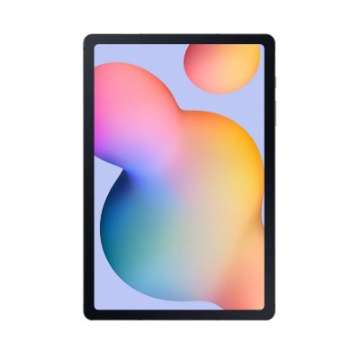

Actual Display Size : 10.4 inches

Operating System : Google Android

Version Number : Android 10

Year of Release : 2020

Average Price : $504 as of 28 09 2021

Internet Access : Wi-Fi Only

## Accessibility Features:

### Cognitive

* Additional Instructions
* Copy and Paste
* Flicker Free Display
* GPS
* Photo Telephone List
* Screen Timeout Disabled
* Simple Instructions
* Simple Reminders
* Simplify Display

Voice Notes

### Hearing Impairment and Deaf

* Allows for sign language communication
* Bluetooth or Wi-Fi
* Closed Captioning
* Front Facing Camera
* Hearing Aid Microphone Coupling
* Hearing Aid Telecoil Coupling
* Vibrating Alerts - Adjustable
* Video Communications - Two-way

Visual Alerts - Incoming Calls

### Vision

* Accessibility APIs supported
* Battery Alert - Audible
* Bluetooth or Wi-Fi
* Braille Display Support
* Brightness Adjustable
* Dictation / Speech-to-Text
* High Contrast Mode
* Personalised Shortcuts
* Power Cue
* Screen Magnifier
* Screen Reader
* Text Size Adjustable
* Text Style Adjustable
* Voice Control /Personal Assistant

Voiced Menus

### Speech

* Allows for sign language communication
* Bluetooth or Wi-Fi
* Messaging Options - Email
* Messaging Options - IM

Predictive Text

### Physical

* Bluetooth or Wi-Fi
* Dictation / Speech-to-Text
* Gesture Based Navigation
* Headset - plug connected
* Predictive Text
* Reduced hand movement option
* Speaker-phone option
* Stylus or Prosthetic Device support
* Switch control option
* Visible Focus Indicators
* Voice Control / Personal Assistant
* Voice Recognition for Accessing Features

Voice Recognition for Dialling

## How and where to get it from?

You can buy this phone from [Samsung](https://www.samsung.com/au/tablets/galaxy-tab-s/galaxy-tab-s6-lite-10-4-inch-gray-64gb-wi-fi-sm-p610nzaaxsa/buy/), [Officeworks](https://www.officeworks.com.au/shop/officeworks/p/samsung-galaxy-tab-s6-lite-wifi-64gb-oxford-grey-s6ltewf64), [JB Hi-Fi](https://www.jbhifi.com.au/products/samsung-galaxy-tab-s7-12-4-4g-128gb-mystic-silver?query=galaxy%20tab%20s6%20lite&page=1), [Mobileciti](https://www.mobileciti.com.au/samsung-galaxy-tab-s6-lite-128gb-wifi-p610-oxford-grey), [Harvey Norman](https://www.harveynorman.com.au/catalogsearch/result/?q=galaxy+tab+s6+lite), [The Good Guys](https://www.thegoodguys.com.au/samsung-galaxy-tab-s6-lite-wi-fi-64gb-grey-sm-p610nzaaxsa), [Buymobile](https://buymobile.com.au/products/samsung-galaxy-tab-s6-lite-p610-4gb-ram-64gb-wifi), [Dick Smith](https://www.dicksmith.com.au/da/shop/?q=galaxy+tab+s6+lite), [Bing Lee](https://www.binglee.com.au/samsung-sm-p610nzaexsa-galaxy-tab-s6-lite-wi-fi-128gb), and other retailers.

## More information is available on:

[Samsung Galaxy Tab S6 Lite Webpage](https://www.samsung.com/au/tablets/galaxy-tab-s/galaxy-tab-s6-lite-10-4-inch-gray-64gb-wi-fi-sm-p610nzaaxsa/)

[Samsung Galaxy Tab S6 Lite User Manual (PDF Download)](https://org.downloadcenter.samsung.com/downloadfile/ContentsFile.aspx?CDSite=UNI_LEVANT&OriginYN=N&ModelType=N&ModelName=SM-P610&CttFileID=7699181&CDCttType=UM&VPath=UM%2F202005%2F20200507100059177%2FSM-P61X_UM_EU_QQ_Eng_Rev.1.1_200427.pdf)

[Samsung Galaxy Tab S6 Lite Support Webpage](https://www.samsung.com/au/support/model/SM-P610NZAAXSA/)